North 1 | United States | 7 |  |  | South 4 | Hawkeye | 112
 | Algeria | 8 |  |  |  | Zimbabwe | 111
 | Argentina | 9 |  |  |  | Zambia | 110
 | Armenia | 10 |  |  |  | Yemen | 109
 | Australia | 11 |  |  |  | Vietnam | 108
 | Austria | 12 |  |  |  | Venezuela | 107
 | Azerbaijan | 13 |  |  |  | Uzbekistan | 106
 | Bahrain | 14 | 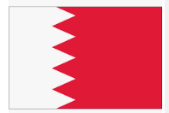 |  |  | United Kingdom | 105
 | Bangladesh | 15 |  |  |  | Ukraine | 104
 | Belarus | 16 |  |  |  | Uganda | 103
 | Benin | 17 |  |  |  | Turkiye | 102
 | Bolivia | 18 |  |  |  | Thailand | 101
 | Brazil | 19 |  |  |  | Tanzania | 100
North 2 | Bulgaria | 20 |  |  | South 3 | Taiwan | 99
 | Burkina Faso | 21 |  |  |  | Syria | 98
 | Canada | 22 |  |  |  | Switzerland | 97
 | Cayman Islands | 23 | 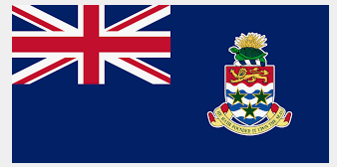 |  |  | Sweden | 96
 | Chile |  |  |  |  | Sudan | 95
 | China | 25 |  |  |  | Sri Lanka | 94
 | Colombia | 26 |  |  |  | Spain | 93
 | Costa Rica | 27 | 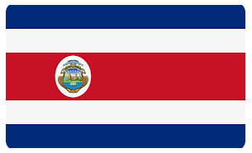 |  |  | South Africa | 92
 | Czech Republic | 28 |  |  |  | Slovakia | 91
 | Dominican Republic | 29 |  |  |  | Singapore | 90
 | Ecuador | 30 |  |  |  | Sierra Leone | 89
North 3  North 4 | Egypt | 31 |  |  | South 2 | Serbia | 88
 | Ethiopia | 32 |  |  |  | Senegal | 87
 | Finland | 33 |  |  |  | Saudi Arabia | 86
 | France | 34 |  |  |  | Saint Lucia | 85
 | Gambia, The | 35 |  |  |  | Saint Kitts and Nevis | 84 | 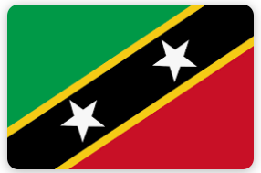
 | Georgia | 36 | 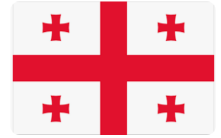 |  |  | Rwanda | 83
 | Germany | 37 |  |  |  | Russia | 82
 | Ghana | 38 |  |  |  | Romania | 81
 | Greece | 39 |  |  |  | Portugal | 80
 | Guatemala | 40 |  |  |  | Poland | 79
 | Guyana | 41 | 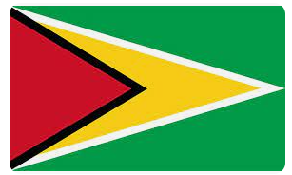 |  |  | Philippines | 78
 | Honduras | 42 |  |  |  | Peru | 77
 | Hong Kong | 43 |  |  |  | Panama | 76
 | India | 44 |  |  |  | Pakistan | 75
North 4 | Indonesia | 45 |  |  | South 1 | Oman | 74
 | Iran | 46 |  |  |  | Norway | 73
 | Iraq | 47 |  |  |  | Nigeria | 72
 | Ireland | 48 |  |  |  | New Zealand | 71
 | Israel | 49 |  |  |  | Netherlands | 70
 | Italy | 50 |  |  |  | Nepal | 69
 | Jamaica | 51 |  |  |  | Myanmar | 68 | 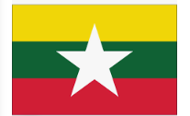
 | Japan | 52 |  |  |  | Mongolia | 67
 | Jordan | 53 |  |  |  | Mexico | 66
 | Kazakhstan | 54 |  |  |  | Mali | 65 | 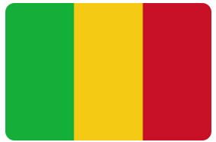
 | Kenya | 55 |  |  |  | Maldives | 64
 | Korea, North | 56 |  |  |  | Malaysia | 63
 | Korea, South | 57 |  |  |  | Libya | 62
 | Kuwait | 58 |  |  |  | Liberia | 61 | 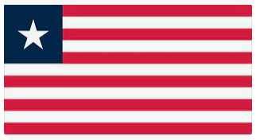
 | Kyrgyzstan | 59 | 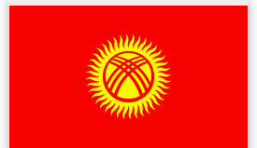 |  |  | Lebanon | 60

